Making Predictions

In 1900, an American engineer, John Watkins, made some predictions about life in 2000. Many of his predictions were correct. Among other things, Watkins predicted television, mobile phones, and digital photographs.
However, predictions are often very difficult to get right. Here are some examples:

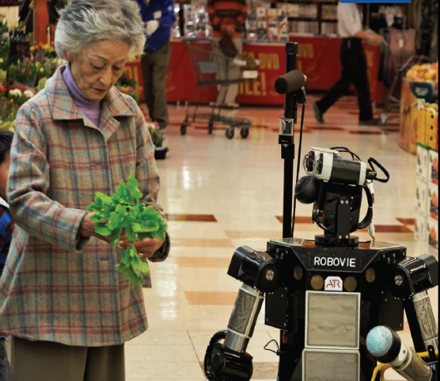
“The telephone [cannot] be seriously considered as a means of communication.”
— Western Union memo, 1876

“I have no faith in [flying machines] other than ballooning.”
— William Thomson, British scientist, 1899

“All the calculations . . . in this country could be done on three digital computers. No one else would ever need machines of their own, or would be able to afford to buy them.”
— Cambridge University Professor Douglas Hartree, 1951
Robovie, a talking robot, helps a 69-year-old woman with her supermarket shopping in Kyoto, Japan

Questions:
- What past predictions were correct?
- What past predictions were incorrect?

Life in 2025
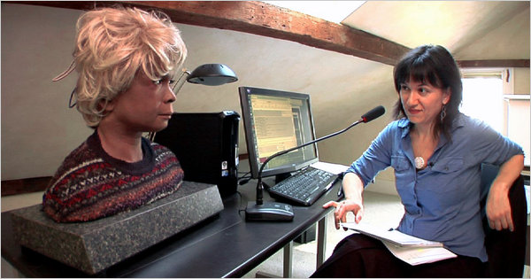
Here are some experts’ predictions for life in 2025:
• Most cars will be electric, and they will drive by
themselves.
• Most of our energy will come from the sun, not oil.
• People will be able to record and replay their memories.
• Most families will own a robot.
• Some robots will have rights, such as the right to own property or run a business.

A woman chats with Bina48, a human-like robotic head

Questions:
- What predictions for 2025 are likely happen, in your opinion?
- What predications for 2025 are not likely to happen? Why not?

